Link

Data set: <https://www.kaggle.com/uciml/red-wine-quality-cortez-et-al-2009/notebooks?datasetId=4458&sortBy=voteCount>

Sample Code:

<https://www.kaggle.com/ananthreddy/red-wine-quality-polynomial-regression?select=winequality-red.csv>

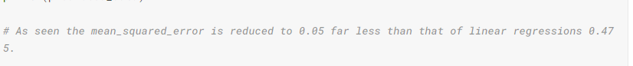

1600 \* 12

Clean Data

Label: 1-10 integer